ALTHEA LAWTON

Women’s Service – 1984

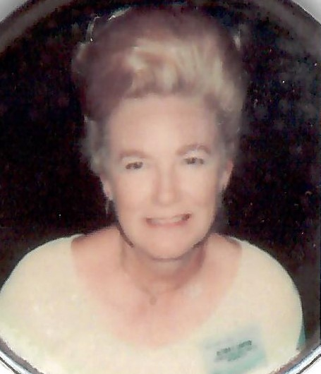

Althea Lawton was inducted in the Hall of Fame for service, but could easily have been for skill as well. In 1961, at Bowlarena she bowled a 290 game. It was the highest sanctioned score ever turned in by a woman bowler in Oklahoma City. The game was worth $1,000 as the city Bowling Proprietors Association had a standing offer of that amount to any woman shooting a 279 or better.

She presided as Secretary of the Koffee Kup League at 66 Bowl for over 40 years. As a bowling instructor, her enthusiasm and love for the game was felt by many. She was described as a gentle and kind soul, having a big heart for animals and babies.

For her dedication and service to the Oklahoma City Women’s Bowling Association the Oklahoma City Hall of Fame proudly inducts Althea Lawton into its Hall of Fame for Meritorious Service.