C. ARMENTA WIGHT

Meritorious Service – 2024

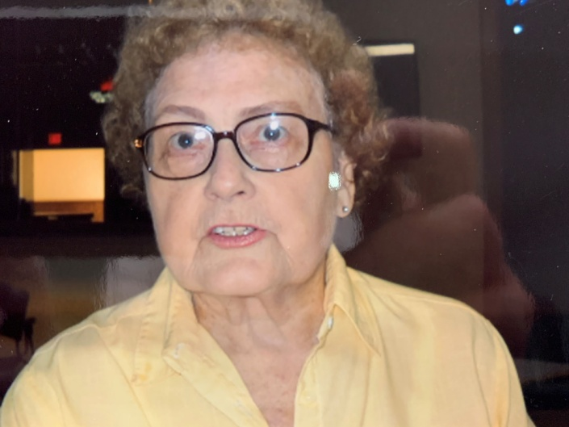

Born in Turkey, Texas, Armenta was a school teacher and bowled for more than 50 years finding her true passion in senior bowling leagues. Credited with the growth and success of the senior leagues in the Oklahoma City area, she served as league secretary for 28 years until poor health forced her retirement. She was honored by the Edmond City Council for her character traits of tolerance and creativity. Oklahoma City Hall of Famer, Jeri Taylor said Armenta exemplified tolerance by not letting differences keep her from being considerate to everyone and therefore she is a “Champion of Character”. The OKC Area USBC Association couldn’t agree more and therefore it gives the Greater Oklahoma City Area USBC much pleasure to posthumously induct Armenta Wight into the GREATER OKLAHOMA CITY AREA USBC HALL OF FAME.