BRIAN FLEMING

Skill/Performance – 2024

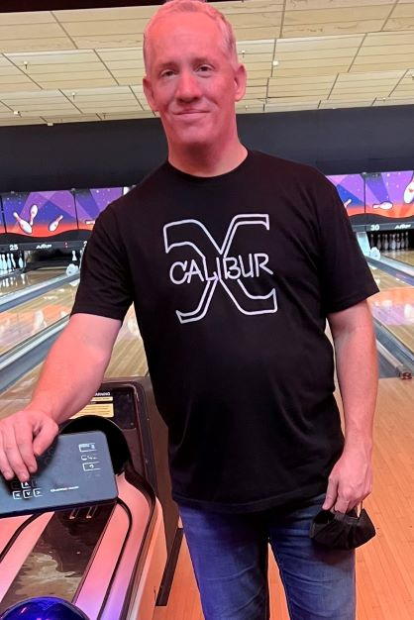

Brian came up through YABA and moved into the adult leagues in his late teens; honing his skills and falling in love with bowling. The salty right-hander has bowled (39) certified 300 games and (11) 800 series with his 857 high as Sunnylane’s house record. He sports an impressive 233 high average (minimum 60 games).

His tournament wins are abundant and include Oklahoma State Mixed All-Events, Oklahoma City doubles, Planet Doubles, Mixed Planet Doubles, Angelo’s Sweepers, Boulevard West Sweepers, Snowman Doubles, etc…

Brian is always willing to help anyone with advice that will improve their game. For his bowing ability and good sportsmanship, it gives the Greater Oklahoma City Area USBC much pleasure to induct Brian Fleming into the GREATER OKLAHOMA CITY AREA USBC HALL OF FAME.