DAVID WHITE

Skill/Performance – 2024

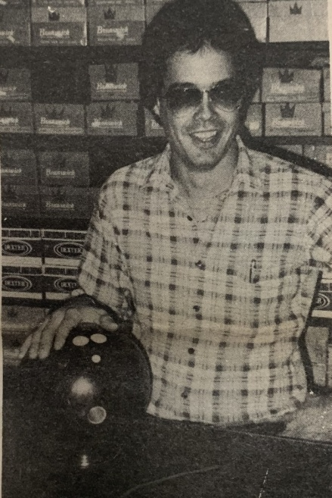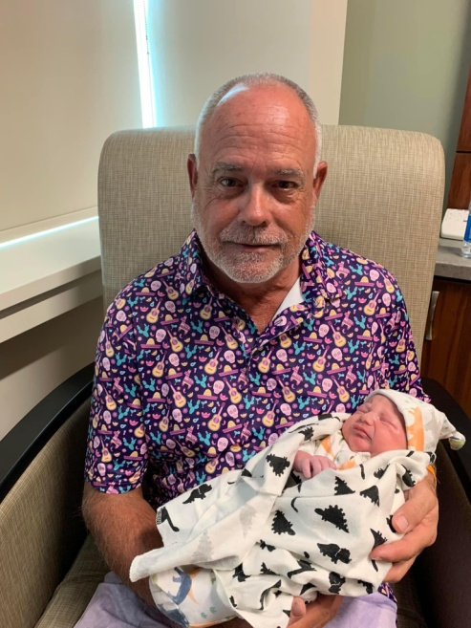

David began his bowling in YBA leagues at Windsor Lanes quickly making a name for himself by shooting 300 at age 15 and soon excelled in adult leagues. Everyone knew how good Whitey was throughout the 70’s, 80’s & 90’s backed by his weekly high games and series posted in the Daily Oklahoman. As a member of the PBA, he bowled 4 of his (33) 300 games on tour, cashing in many Professional, Regional and Local tournaments. His 864 high series was a state record for some time and he sports a high 228 average as well as (8) 800 certified series. He managed Windsor Pro Shop and Boulevard West before making the move to the Memphis area. For his outstanding bowling skill, it gives the Greater Oklahoma City Area USBC much pleasure to induct David White into the GREATER OKLAHOMA CITY AREA USBC HALL OF FAME.