FLOYD CARNES

Men’s Veteran Skill – 2002

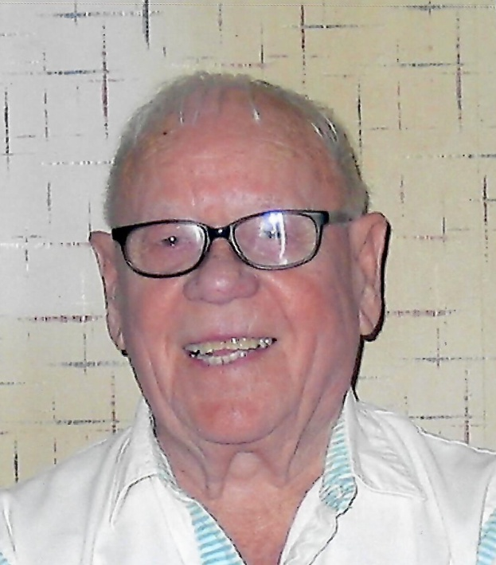

Floyd Carnes was known as a high roller with many 300 games to his credit. He often led the honor roll for Senior’s and made a name for himself. Little more is known unfortunately.

For his bowling skill, the Oklahoma City Hall of Fame proudly inducts Floyd Carnes into the Hall of Fame.