JIMMY McMARTIN

Skill/Performance – 2023

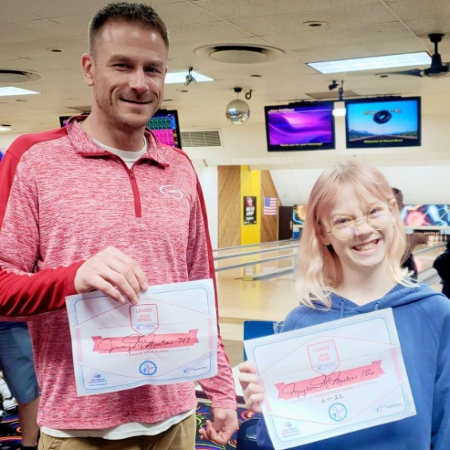 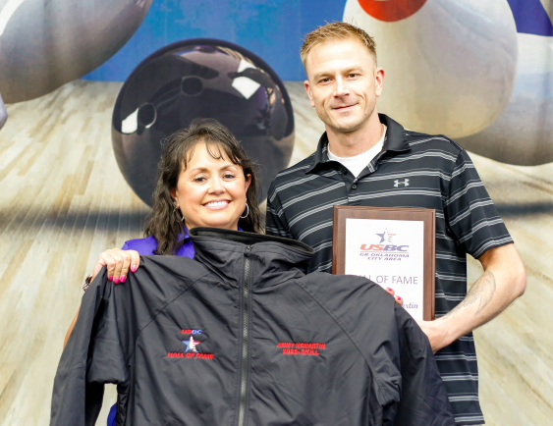

Jimmy began his bowling in Youth leagues at Holiday Lanes and was twice named Oklahoma YABA Bowler of the Year. He only got better from there! Jimmy has won or placed in so many bowling tournaments we can’t even begin to list them.

He dons more than (100) 300 games, more than (40) 800 series, the high being 857. He is consistently on the Top 20 average list in the Greater Oklahoma City area and has a high league average of 244.

Jimmy has cashed in multiple Professional, Regional and Local tournaments. As the above picture shows, he is very proud of his family. We are sure this is just the beginning for Jimmy and we are glad he will be in this association for us to watch!

For his outstanding bowling skill, it gives the Greater Oklahoma City Area USBC much pleasure to induct Jimmy McMartin into the GREATER OKLAHOMA CITY AREA USBC HALL OF FAME.