JUNE HUSTED

Women’s Service – 1983

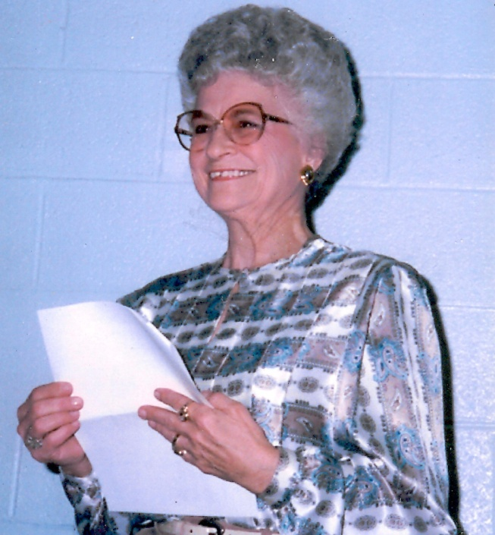

June Husted was well known in the bowling world, serving 25 years as the Secretary of the Oklahoma City Women’s Bowling Association and State Bowling Association. As June McNeil, she worked at Windsor Lanes house secretary and often nabbed the weekly bowling honors as she was quite the bowler as well. Her devotion to the sport was unmatched and her charm and genuine kindness made her one of the most well-liked bowlers around. Her work continued after her induction and in 1990 presented Leanne Barrette a plaque naming Barrette to the Woman Bowler magazine’s 1989 All-American team.

For her bowling dedication and love for the sport the Oklahoma City Hall of Fame proudly inducts June Husted into the Hall of Fame.