LARRY GODFREY

Men’s Skill – 2002

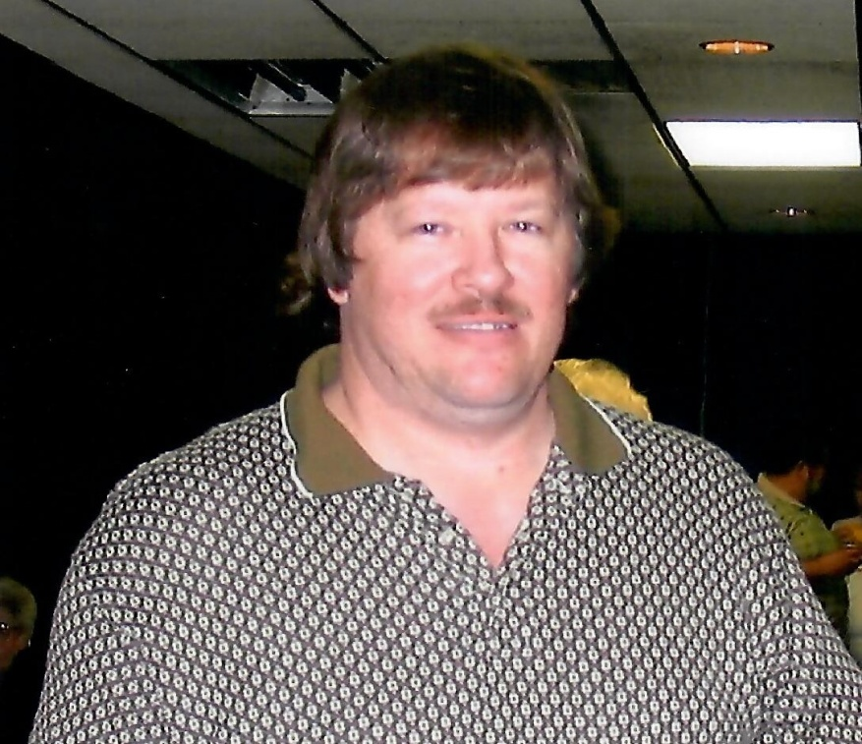

Larry Godfrey can bowl!

The number of honor scores this man has bowled is not known for certain, but there are plenty! He was averaging 235 back in 2001. He was a member of TEAM DIVIDED in 2003 in the Thursday Business Men’s league at AMF Yukon Lanes when his 5 member team bowled 1270, 1113, 1282 for 3665 scratch.

His bowling skill alone speaks for itself and the Oklahoma City Hall of Fame rightfully inducted Larry Godfrey into the Hall of Fame.