LOIS PETTLE

Women’s Service – 1979

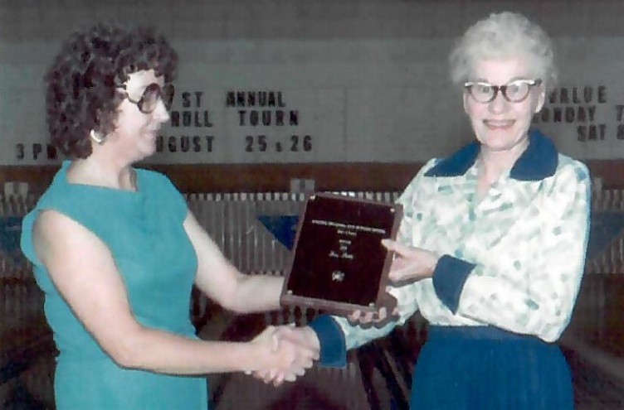

Lois Pettle has devoted many hours to the Oklahoma City Women’s Bowling Association. Having been a member for 23 years and attending all but 2 annual meetings of both City and State she is likely not to slow down anytime soon. She has served as league secretary, Oklahoma City Vice President, Director as well as State director and 3rd Vice-President from 1982-1985. She says she enjoys work and personal associations with bowlers.

For her dedication and service to the Oklahoma City Women’s Bowling Association the Oklahoma City Hall of Fame proudly inducts Lois Pettle into its Hall of Fame for Meritorious Service.