MARGE PINION

Women’s Skill – 1984

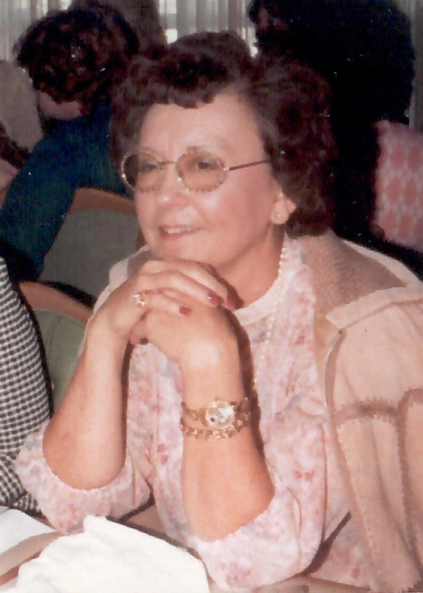

Marge Pinion was a champion of champions – a true competitor until the end. Marge was always leading the honor rolls week after week from the 70’s thru the 80’s. She was an advocate for the scratch bowler, heading up the Women’s Masters Travel league in 1973 as well as the Windsor Women’s Scratch trio the same year. She often won singles tournaments and did bowl professionally some. In 1980, she won her fourth Great Plains Bowling Association crown, worth $250 at the July tournament in Kansas City. In November 1974, she took the top honors among the women with a high game of 257 but also rolled her first 700 series, an un-sanctioned 715 in the sweeper at Planet.

For her dedication, knowledge and competitiveness the Oklahoma City Hall of Fame proudly inducts Marge Pinion into the Hall of Fame.