MARY LAVARNWAY

Women’s Service – 1990

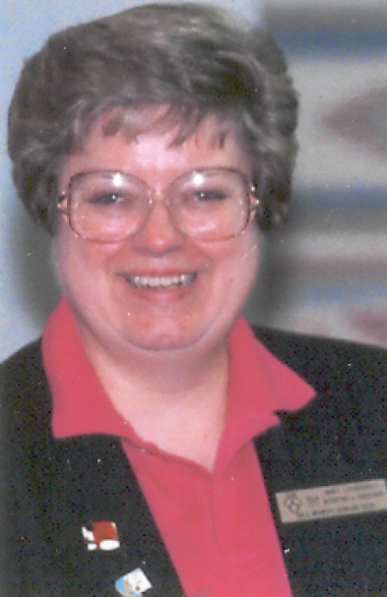

Mary Lavarnway spent many days and nights devoted to bowling. She served as director of the Oklahoma City Women’s Bowling Association for 14 years. She has been a sanctioned bowler for 21 years, was secretary of the Oklahoma State Bowling Proprietors Association for four years and is currently a YABA director at Penn 44 Lanes. She loves her youth bowlers and does a fantastic job helping them in any possible way. She is such a classy lady and gets along with everyone. Mary is an accomplished bowler as well leading the weekly honor rolls many times throughout the 70’s and 80’s.

For her dedication and service to the Oklahoma City Women’s Bowling Association the Oklahoma City Hall of Fame proudly inducts Mary LaVarnway into its Hall of Fame for Meritorious Service.