ROSEMARY SMITH

Women’s Skill – 1982

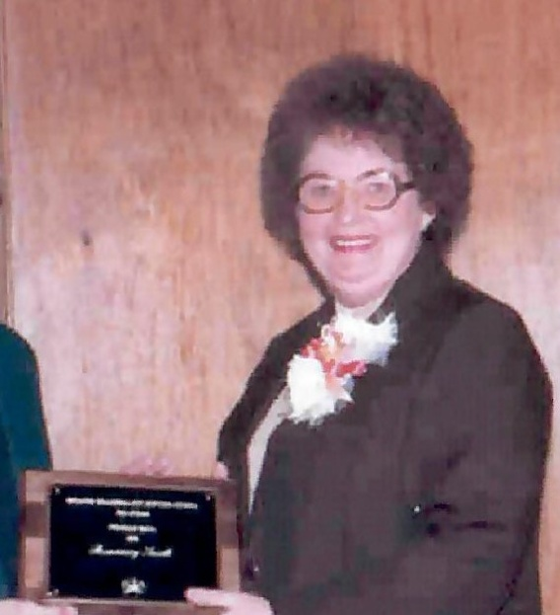

Rosemary Smith was the bowler to beat throughout the 1940’s, 1950’s, 1960’s & 1970’s. She was often listed as one of the top 20 female bowlers in the Oklahoma City area. She graduated from El Reno High Schoo in 1943 and was a “Rosie the Riveter” at Douglas Air Craft during WWII. In 1947, Rosemary captured the Times Classic Championship and in 1956 won Harpman’s Round-Robin Championship. She would often end up with her picture in the paper bowling a fantastic score. In 1955 her 844/4 games with handicap topped 400 other women to capture her second Times Classic Championship and the $1000 prize.

For her bowling ability and perseverance the Oklahoma City Hall of Fame proudly inducts Rosemary Smith into the Hall of Fame.