SHIRLEY COTHAM

Women’s Service – 1988

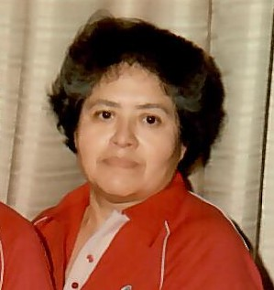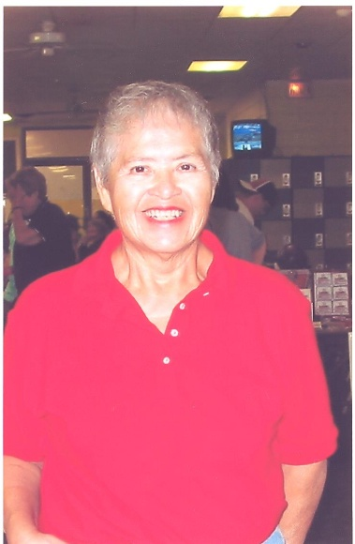

Shirley Cotham, a sanctioned city bowler for 25 years was inducted into the Oklahoma City Hall of Fame for her service in 1988. She has been Director of the Oklahoma City Women’s Bowling Association for 14 years and Director of the Oklahoma State Women’s Bowling Association for 6 years.

For her dedication and service to the Oklahoma City Women’s Bowling Association the Oklahoma City Hall of Fame proudly inducts Shirley Cotham into its Hall of Fame for Meritorious Service.