CHRIS SKILLINGS
Men’s Service – 2022
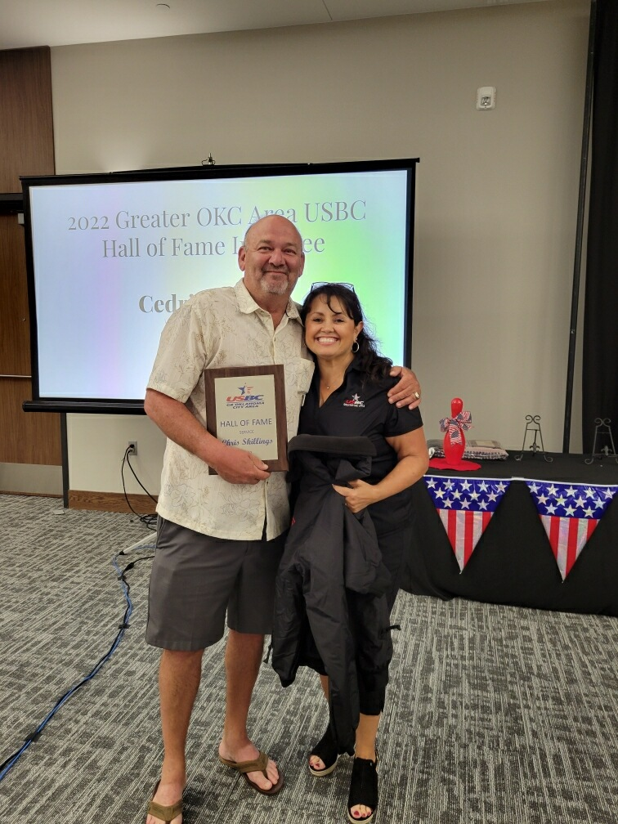

Chris Skillings, a Shawnee native began working in the bowling industry in 1979. He is the current Owner of Operations at FireLake Bowling Center. He has been a sanctioned bowler for 48 years and a member of the Southwest Region PBA Hall of Fame since 2014. Before merging with the Greater Oklahoma City Area USBC Association, he was a member of the Board of Directors in the Shawnee Association. He has served in the capacity of team captain, league officer, association officer, league coordinator, tournament organizer, special event organizer and tournament official. He has hosted more than 40 Regional PBA and 15 National PBA events. Being the host for Big Brothers/Big Sisters of Shawnee for the past 10 years as their only fundraising event certainly speaks well of his deserving induction.

