TIM DENNY

Meritorious Service – 2025

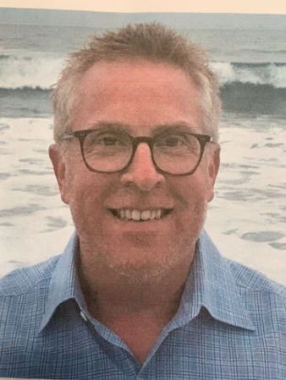

Born in Long Beach, California, Tim’s family moved to Oklahoma City at age 14, where he joined a youth bowling league with his brother, Kevin. This began one of his lifelong passions. He had great knowledge, amazing skill and was a fierce competitor. The lefty was a very accomplished bowler – bowling several 300 games and 800 series. In the 2004 – 2005 season Tim averaged 235 which was 1st in our Association. In 2018, with wife Kim, they purchased Holiday Lanes quickly learning all aspects of the bowling industry. They invested in new lanes, scoring machines and made many cosmetic changes. Tim helped create the Denny/Brown scholarship tournament for youth bowlers and was a big supporter of the SASBA Tour. He supported “Bowl with the Pros”, a local tournament for handicapped bowlers that just love to bowl. Tim gave back to the community whether thru the bowling center, involvement with local organizations, or just by sending encouraging messages via texts or phone calls. Tim left us on March 28, 2025. He is missed by many, but respected and admired by all. His friends & family knew him as TFD and now he will forever be known as HOF as well – Hall of Famer! It gives the Greater Oklahoma City Area USBC much pleasure to induct Tim Denny into the GREATER OKLAHOMA CITY AREA USBC HALL OF FAME.