TONI CALVARY STARIN

Women’s Skill – 1978

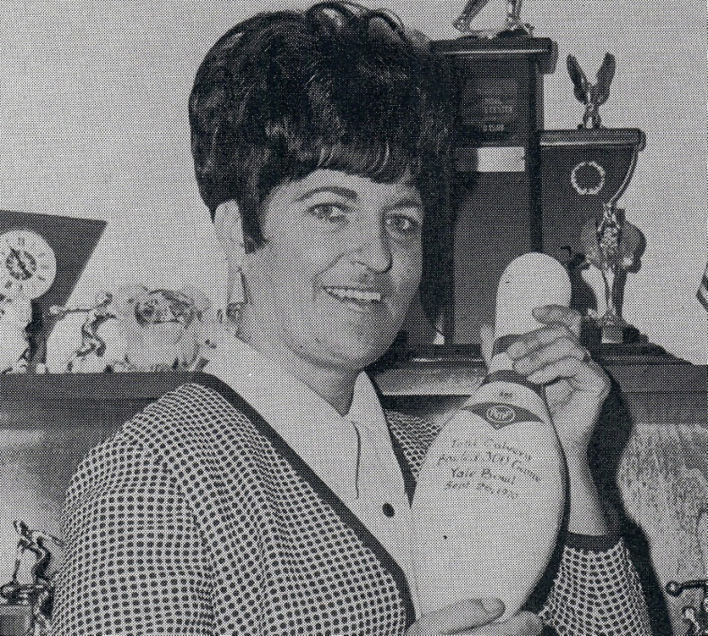

Toni Calvery Starin was perhaps Oklahoma City’s finest female bowler. She began bowling in 1958 and in 1973, the Midwest City lady pro and University hospital supervisory employee scored, 1910 to win all-events in the WIBC’s record 1973 tournament at Showboat Lanes, Las Vegas. She traveled the country competing in professional women’s tour events, cashing in many. She actually helped organize the Professional Women’s Bowling Association. She won the State Queen’s tournament and had a 300 game to her credit.

For her bowling skill, dedication and love for the sport the Oklahoma City Hall of Fame proudly inducts Toni Calvery Starin into the Hall of Fame as a Charter Member.