TRACY CAMPER

Skill/Performance – 2025

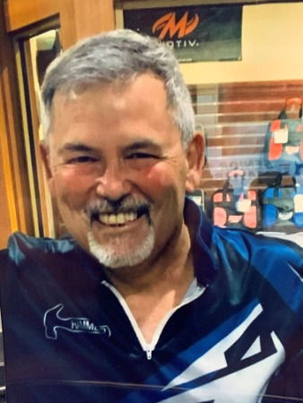

In 1971, Tracy began bowling in Houston, Texas, when AJBC (American Junior Bowling Congress) governed the youth division. That year he received a certificate for perfect attendance with an average of 56 for 40 games. Boy has he come a long way! He’s been in the GR OKC bowling community most of his life growing, competing and helping others. A few minutes spent with Tracy and you realize what a genuine, spiritual, family man he is – He just happens to be an exceptional bowler as well. With a high average of 226 he sports a high series of 847, bowled in 2024. Tracy has bowled 300 games in his 20’s, 30’s, 40’s, 50’s and 60’s. He’s won too many tournaments to list and is proud to have been a PBA member over 17 years, cashing for over $9,000. He owned and operated his pro shop since the Mid 80’s, helping bowlers with their game. Tracy also found time to volunteer, coaching Piedmont High School Bowling for 6 years, advancing to regional & state finals. Tracy will be the first to tell you that his Savior and Family come first but bowling is his passion. He is a great ambassador for our sport, our community and our state. For his good sportsmanship, humbleness and bowling skill, it gives the Greater Oklahoma City Area USBC much pleasure to induct Tracy Camper into the GREATER OKLAHOMA CITY AREA USBC HALL OF FAME.