VICKI FREDERICK

Skill/Performance – 2023

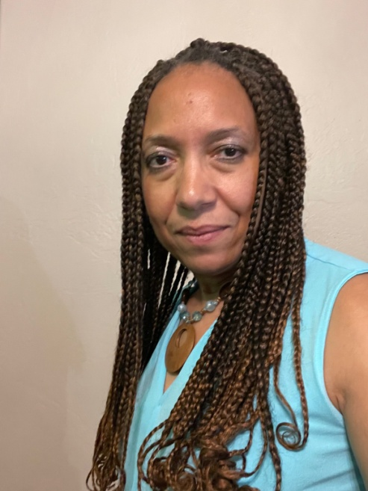 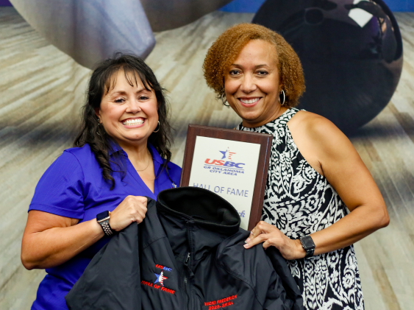

A native to Bartlesville, Oklahoma, Vicki started bowling at the age of 6, being coached by her mother and a few other influential people. After taking a few years off while attending the University of Oklahoma, she eventually came back to the sport she loves and has been a certified bowler since 1994-95 season. In 2021, Vicki became the first woman to bowl an 800+ series at AMF Boulevard Lanes. She has three 300 games to her credit as well and booked her highest career average of 216 in the 2018-2019 season.

Described as a lady that blances her work, bowling and family beautifully, it gives the Greater Oklahoma City Area USBC much pleasure to induct Vicki Frederick into the GREATER OKLAHOMA CITY AREA USBC HALL OF FAME.